MENOMONEE FALLS HISTORICAL SOCIETY
ANNUAL REPORT
2022

MENOMONEE FALLS HISTORICAL SOCIETY
Minutes of the annual membership Meeting
January 30, 2022
Village Bowl – Bugline Room

After the meet and greet Vice President Diane Harley invited the 36 members in attendance to enjoy the Italian Buffet with cheese cake for dessert.
Annual Reports were available for the members thanks to Jill Schmidt.
Richard opened the meeting at 1:15 and thanked the Board members and volunteers for making 2021 a successful year for the Society.
The 2021 Silver Tea chaired by Jill Schmidt sold $1000.00 in cookies; Jill said she will need more bakers next year!
Richard challenged all events chairs to increase their revenue by 20% this year.
This year we’ll be adding a Revolutionary War as a new event. The dates are May 21 -22,
This year’s beer garden will have several different added attractions; a horse & carriage ride and a sci – fi day are planned. There will be others throughout the season.
If would be nice if we could get sponsors for the entertainment during the beer garden.
Grace Commons is interested in a sponsorship, hopefully the band for the USO Dance,
Richard & Bill Schulz will meet with Mark Fitzgerald to ask if there’s village money to do park improvements, like the need for new bathrooms. Would be nice to have a heat pump in the Depot, it could then be opened more than just in the summer months. The center part of the Depot will be reconstructed by putting in a ticket booth. The baggage section will remain the museum.
A mural is planned for the east side of the Carriage House advertising the beer garden.
Other things planned for this year are; buy a retractable awning for over the stage, create walking paths throughout the woods and a prairie garden south of the creek.
Jeff distributed and talked about the financial statement. There were no questions.
Nominations & Election of Board of Directors
Due to the change in the By Laws 4 or 5 directors will be elected annually for 3 year terms. The Board of Directors, not the entire membership will nominate & elect the four officers.
This year’s nominees;
Richard Burgess
Jim Cichy
Monika Oeltjen
Todd Schuman
No nominees from the floor. A vote was taken and the 4 Directors were elected
All are elected for 3 year terms.
The remaining Board members are;
Diane Harley
Jeff Steliga
Chris Schultz

Jordan Euclide
Marlene Fay
Jill Schmidt
Vikki Schmidt
Bill Schulz
Jeremy Walz
Volunteer of the Year Award
Diane told us this volunteer has been with the Society since 1997, took over Halloween Family Fun Nights and made it a very successful event over the years. She also served as Society President. She’s known for the knitting & quilting, plus the cute Christmas characters she knits and we sell during Silver Tea.
She has organized many Silent Auctions over the years. The volunteer is Vikki Schmidt. Vikki thanked the members and told us a little more about the other things she does.
Reelect President Richard Burgess for a 3 year term.
Bill Schulz moved we reelect Richard, Diane, Jeff and Chris to their officer positions, Marlene seconded. they have been reelected for another 1 year term.
Long time member Danno Walker passed away this week. Ken Pruess asked the Board if they’d consider adding the Walker name to the Sparrow Cabin as his family once owned the cabin. Richard said the Directors will discuss it at the next Board meeting.
Before the entertainment started Bob Cowan asked if there were things older people could do to help. Bill Schulz is going to suggest we have some type of email messaging to let people know when they’re needed.
‘GREAT SCOTT’ the magician was the entertainment for the afternoon.
A few of the fun things he did were;
He had Jill up front doing tricks with rings, which didn’t work well for her.
Had Diane Cowan play with a container of coins.
Put a suit on Todd Schuman, stood behind him with his hands in the sleeves and did tricks. He made a balloon dog & presented it to Todd.
He played with Jim Cichy’s hundred dollar bill, plus many other magician tricks.
Susan Steliga was his choice to put words on a board that people gave to him. Three words were revealed & they were the words that were chosen.
It was an enjoyable program.
Numbers were put at all the table settings for the 5 gift cards. The number chosen was 3 -Sharon Granke, Maria Pupak, Marlene Fay, Doris Durdan, and Ken Pruess each got a card.
Richard called to adjourn the meetings, Chris moved, Denise seconded, the meeting adjourned.

Chris Schultz,
Secretary
2/6/2022

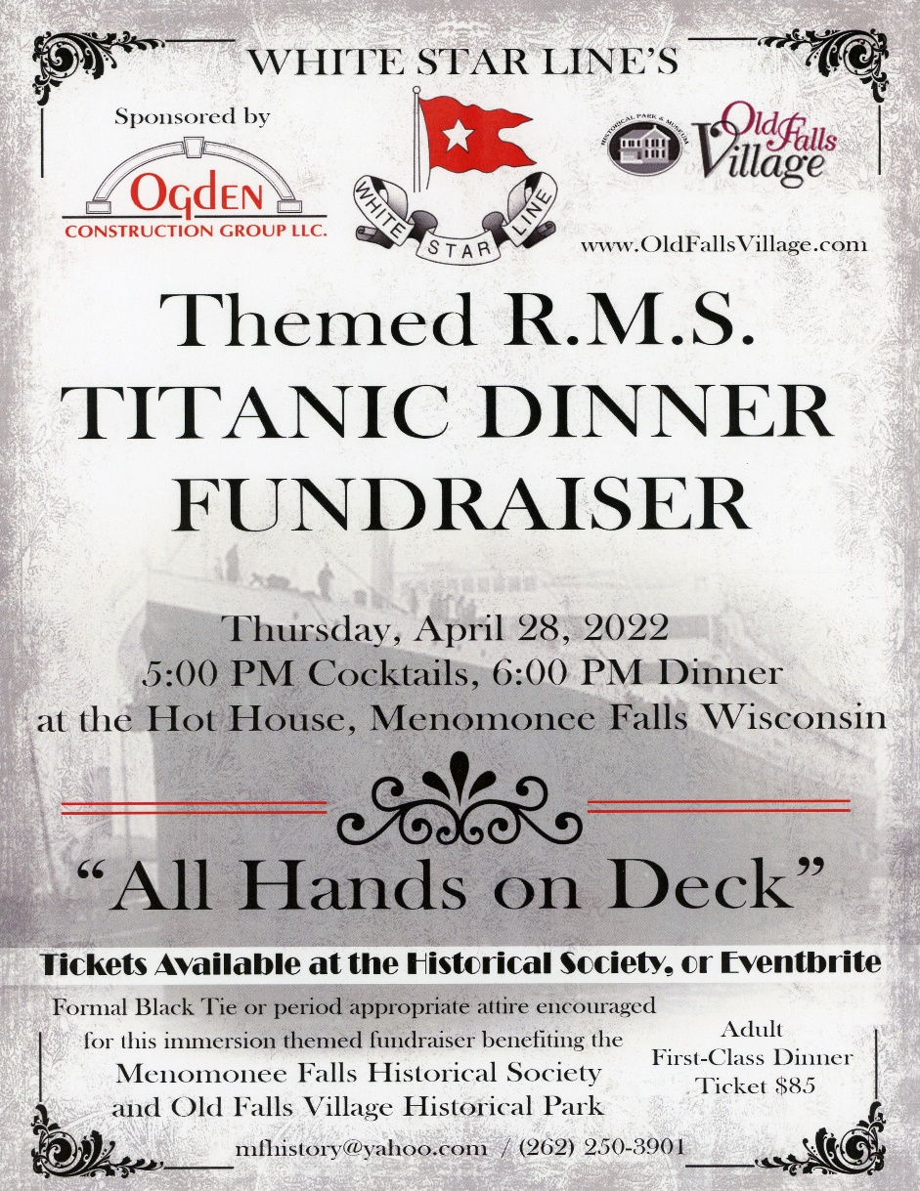

Titanic Dinner
Richard Burgess
The first big event this year was the Titanic Dinner held on Thursday, April 28, 2022. The dinner event chaired by Nancy Griefenhagen, was a recreation of the last dinner served in the first-class dining room on board the RMS Titanic. Held in the Opulent second floor banquet room of the Hot House Tavern, guests were greeted at registration and provided with a name tag giving them their character name, a biography of that person, and a boarding pass for entry onto the ship. If the passenger desired, they could have their photograph taken by Nancy in front of a backdrop of the Titanic grand staircase.
A short walk led the guests off the dock to a red carpeted gangway. Met at the end of the gangway by a ship’s officer, the passengers were directed to their table in the dining room. Along one side of the room were tables containing the many silent auction items available for passenger bidding. At the far end of the room an archway let to a cash bar and high- top cocktail tables.
The passengers were resplendent in their 1912 period costumes, women in their best gowns and long gloves and the men in white tie, top hat and tails. Three of the ship’s officers were present in their double breasted dark blue uniforms.
During the cocktail hour the passengers got to mingle and meet the other travelers. At six o’clock Captain Smith (Richard Burgess) announced that dinner was served, and everyone took their seats. We were lucky that the passenger list included Mme. Aubart (Julie Thompson), a famous French singer, who graciously agreed to sing “Pure Imagination” to help set the fantasy tone for the evening. When Mme. Aubart finished singing, Captain Smith welcomed everyone on board. The captain remarked that the RMS Titanic was a British ship, and it was customary to drink a toast to the King. A round of champagne was poured and a toast to the health of King George V was given by the captain. The captain gave a short prayer, the string quartet began to play, and dinner was served.
A six-course dinner worthy of a five-star restaurant was prepared by the chefs of the Hot House who modeled it after the original First Class 1912 dinner. The courses began with oysters, either raw in a vinaigrette or as Oysters Rockefeller. The oysters were followed by lamb tomahawks broiled to a perfect medium and accompanied by a fresh mint sauce. Next came a cress salad and crispy pheasant. The Intermezzo, a short break in the courses, came next and was graced with a peach sorbetto and chartreuse gelee. Steer tenderloin with foie gras, new potato and snap peas followed the short break. To finish, the chefs treated everyone to chocolate eclairs. The service was excellent and easily could have been aboard the great ship.
During the Intermezzo course, Captain Smith gave a short presentation with the statistics and construction of the RMS Titanic. The captain’s presentation was followed by Lt. Murdoch (Jim Cichy), whose slide program explained the features of Old Falls Village Park and the many events that are held at the park. Molly Brown (Diane Harley), another passenger, conducted a trivia contest about the Titanic. Molly awarded a gift card prize to the winner after a runoff over the four-way tie. At the conclusion of the dinner the captain persuaded Mme. Aubard to sing a couple more songs concluding the evening’s program.
The passengers continued to enjoy the atmosphere until the silent auction ended around 9:30. As the guests made their way to pay for the auction items, they were able to look up the name of their character and see if they had survived the sinking.
I had a chance o talk to each of the ten tables and the comments were overwhelmingly favorable. It was obvious that everyone enjoyed the night of make believe accompanied by an outstanding meal.
We all owe Nancy a big thank you for her ideas, planning and accomplishment of an outstanding event. It drew attendees from as far away as Oshkosh and throughout the Milwaukee metro area. Her challenging work and innovative ideas made the dinner a true “Night to Remember.”

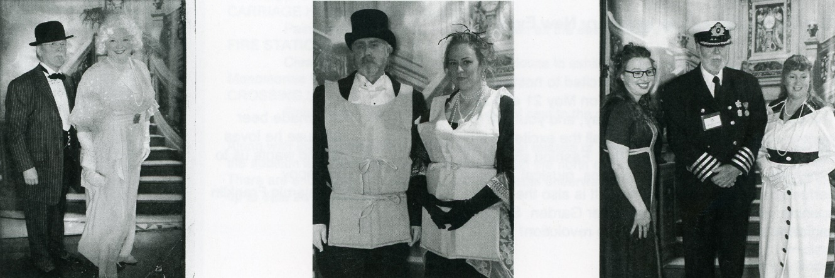

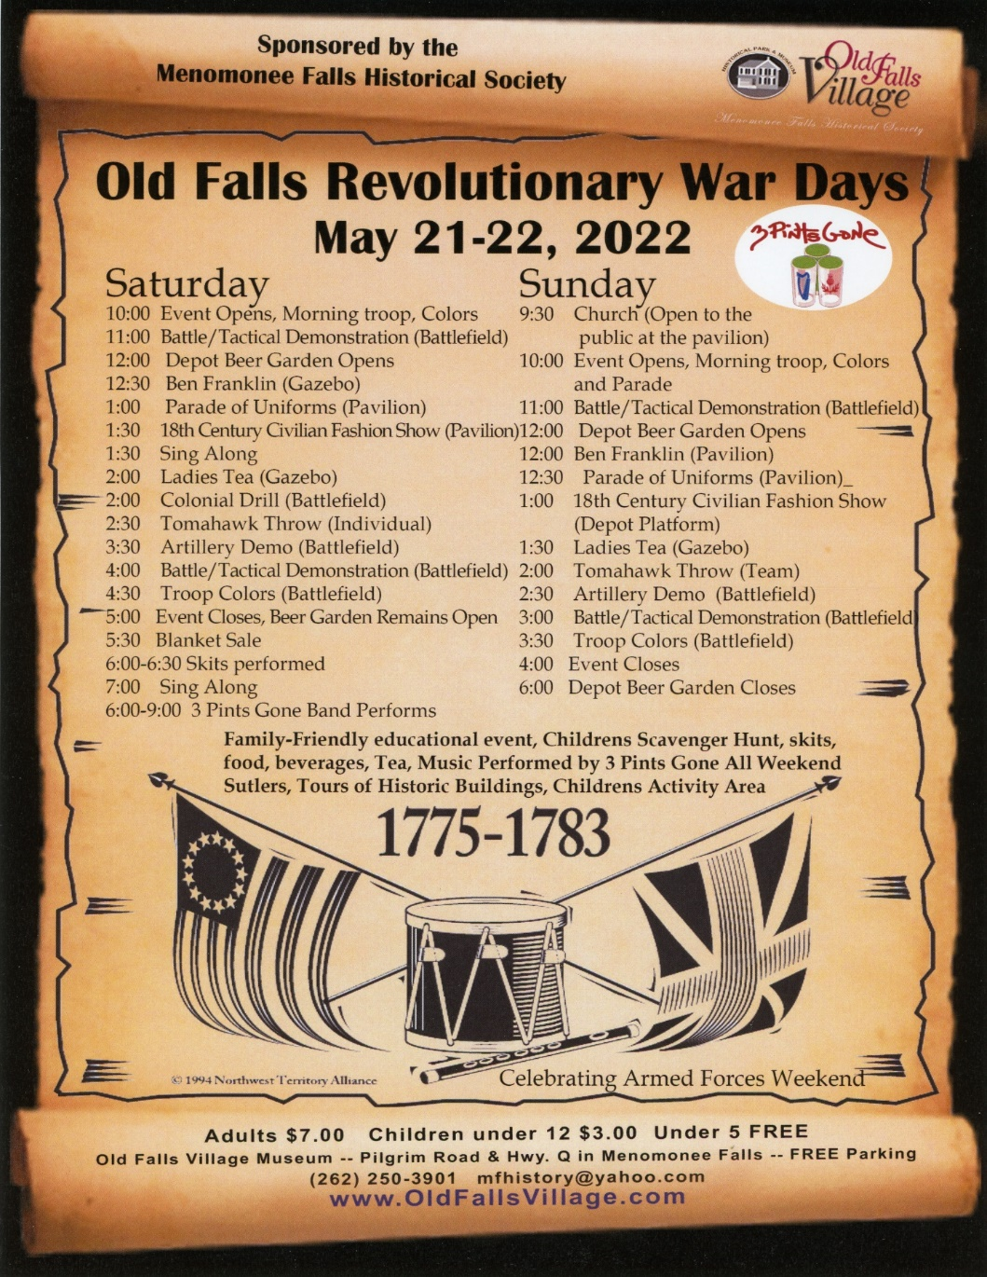
First Annual Old Falls Revolutionary War 2022 Report
Nancy Greifenhagen Co-coordinator with Richard Burgess

On May 21 and 22, 2022, The Menomonee Falls Historical Society had its first Revolutionary War reenactment with the NWTA North West Territory Alliance group from Illinois. It was extremely successful on many levels. To date, this was our most successful event at Old Falls Village Park.
The NWTA group charged $300 to have them come to Old Falls Village and put on a reenactment. They were worth every dollar. We look forward to them coming again next year.
Set up
It was neat to see the park through fresh new eyes. They were unfamiliar with the park, and it was interesting to notice that the reenactors did not know where the bathrooms were, where they could drive, and what was the main hub of the park. The main parking lot was easy to find, but then it was difficult for them to find our registration table behind the barn.
The NWTA group helped with registration from 11 AM until 10 PM. With the help of Pam and others, the registration went really smoothly. They were great help. They did not arrive as early as some of our other events. We did not need the 8 PM meeting which we cancelled. They also did not take as long to set up which was nice. One thing, they really knew how to park so well along Pilgrim Rd in the reenactor parking lot with all the trailers. It was great to see.
Straw
We were asked to get 25 bales of hay for the reenactors to use as bedding inside a mattress bedsheet. They only used 9 bales. With the threat of rain, we kept the straw bales in the carriage house. It is best to have them bring their own straw. We also thought a great idea for school days next year is to have the kids experience laying on a mattress of straw as an example of how people lived on the battlefield in the Revolutionary War days.
School Day Next year.
Next year we would like to incorporate a school day and have some activities for the kids to do. One great comment that we heard was that they really liked our kid’s scavenger hunt. The kids then had a reason to talk to the reenactors. It was a great “ice breaker” with the public. Also, we noticed that each group was very engaged with the public showing them around the camp. Next year, as a suggestion from Ben Franklin, we give the kids a bigger prize at the end of the day or put their names in a pot for a grand prize. I liked that idea. The NWTA’s plan is to use the scavenger hunt at other events which is a great compliment.
Firewood
They used almost all of our wood up that we had stored. They must have burned a lot all day and also cooked with it. We will need to get a lot of wood for next year especially if we have a school day which is an additional night. We had three long stakes of wood 5 feet tall and all but a little left has been used.
Video
Cable Access did some footage of the event and took some drone shots of the battle and park. This was a great addition to our promotion, and it showed the event in a way not seen before. It did not look like a lot of people on the ground from in the air, but the park can absorb so many people.
Details
We had all the houses open this year and another boy scout group helped with parking on Saturday. The weather this year was windy and chilly at times. We only had rain on Thursday afternoon for two hours, but the rest of the time, the rain held off even though it looked like rain. Sunday was sunny and breezy. Overall, the weather was great.
Battles and Presentations
The cannon group only came on Sunday, so the battles were better on Sunday. The artillery group Alexander Hamilton’s Artillery charged us $200 for the powder, but next year it should only be a little bit more in cost. We did like the idea of two battles on each day. I also like the narration that they all did for their battles and demonstrations. They had a fashion show that they narrated, and the pavilion became the place to talk for everyone.
EmCee
Jessica was our emcee for the event and did a great job. We will need to not have announcements when there is a presentation going on. The new PA system and speakers were a bit loud in some areas.
Bands
The band Three Pints Gone were amazing. We will love to have them back again next year. I think a marching flute band would be nice like on the battlefield. The band that showed up unannounced, Col Webb's Band of Music. They were great with period songs and they engaged the public into dancing traditional dances. I would recommend them next year and will need to pay them their fee. This year, they received a lunch ticket.
Admission
We met so many new people and a great outcome of a new event is that we received 22 new memberships including a Lifetime membership. We also started the Eventbrite advanced ticket sales and we sold about $318 worth of 24 tickets online with 5 memberships. It does pay to have advanced tickets without refunds online. I recommend doing that for all events. The admission was $7 and the Eventbrite fee was tacked on to equal $9.
The totals including booths rented, admissions, advanced tickets, memberships, food and beverages, we took in around 13,000 dollars which is the most an event took in during our history. We certainly could have had many more people enter the park and the parking lot was not full all the time. We raised the admission to $7 while keeping the children 11-5 as $3 and Veterans $3. We used the square at the west admissions, food and beverage tables which really made a difference in our totals for the day.
Our flyer and signage was really neat and added to the ambiance of the event.
One of the common comments by the reenactors was they felt that there was not enough bathrooms and two port a johns. We did have enough to cover the crowd for the weekend.
We went through 10 twenty-pound bags of ice which was a lot and we got another 10 bags of twenty pounds but they were mostly left.
Layout
The British were to the far east of the property and the colonials were by the Koch house. We had the civilians by the path along the gazebo and the vendors right by the school. The battle used both sides of the creek and they made a trail in the forest for the ambiance of the battle. I liked how all the tents were lined up in a row. They used twine which we supplied.
We look forward to next year’s event. I believe this is an event that will grow with the public and especially grow with the children’s school day added. I recommend charging at least $5 per child and opening to homeschoolers as well.

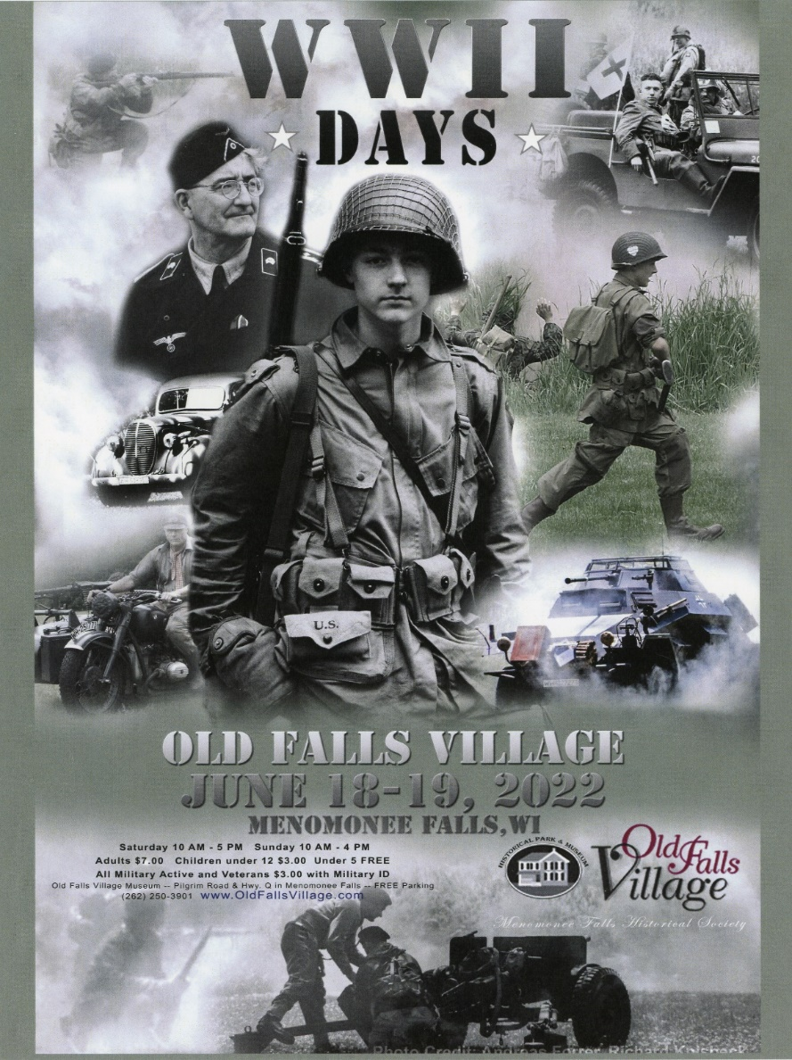
WWII Days 2022 Report
Nancy Griefenhagen
In our fifth year of having the annual event, we continue to exceed our expectations. WWII Days 2022 was a record-breaking event at Old Falls Village. We had the biggest event in reenactors, visitors and income. We had so many visiting reenactors from 4 different states attend as well as visitors coming from far distances just to see WWII Days at Old Falls Village. Every year the event gets bigger and even better.
The weather was outstanding this year. We had a beautiful three-day weekend with nice temperatures, not too hot and not too chilly. We were blessed with so many great things aligned for the best weekend event the park has ever seen.
This is a HRS (Historical Reenactors Society) event. This year was hosted by the RS 41 Royal Marines Commando British commanded by Joe Olson.
Income
Although the final numbers are not confirmed, the Historical Society reached almost $20 thousand dollars in sales. We used the square at the west entrance, beer garden and food line. This made a big difference in sales since people did not have to have cash on hand. We did have lots of requests for an ATM because cash is needed for some items as well for vendors. We had income from vendors paid ahead of time and we also created advanced tickets online at www.eventbrite.com. The fees were added onto the sale, so we received the whole ticket price after the event via a check. We offer no refunds for advanced sales. We also gained 45 new memberships to the Historical Society.
Setup
We had a tent set up outside of the barn for registration. The 2 forms are cumbersome, and it would be better to have the waivers filled out on Eventbrite or our website beforehand. Reenactors start arriving on Thursday, but most arrive on Friday after 11. We had trailers parked at Wacker and people even asked for that since the trailer parking is difficult across the creek. I had vendors park along the tree line by the Koch house to help with less cars in the parking lot.
Ice is given out to the vendors, and we went through about fifteen 20 lbs. bags. We were also short on firewood since the Revolutionary War event used up most of the wood. We ordered from Blaze Landscaping who delivered a cord for $215 on Friday morning. We went through about 90% of that wood plus some of our existing stock. After the event, the two dead trees (one maple by the Miller Davidson House and one ash by the Koch house were taken down.)
We were short on Porta johns for the first time. We should have had another regular porta john or more. The handicap filled up too quickly since it is a smaller tank. Porta johns did not pump out until just before 10 am and I called three times to their emergency line. There were lines for the bathrooms. We need more stalls desperately.
It was sunny all weekend and there should be plenty of cold water for sale and available for the public to buy. Dehydration is a worry at outdoor events.
Battle at 2 PM
The battle crossed over the creek and was choregraphed by Mike Boden which had several elements and complex timing to the advances. He used the trees, logs, and our newest Hedgehogs to make the battles one of our best. We want to thank Bob Piedmont for all his hard work in building the 8 hedgehogs for the battle and for Richard and Jim for painting them. They will be stored in the Steichen house.
Silent Auction
We had a silent auction in the half-painted Depot that is under redesign this year. The Silent auction brought in about $1200.
Entertainment
Jodi has her French Café on the Depot platform that is always a great addition. This year we had three singers that entertained during the Day: Jean, Nicole and Gretchen. The Jazz Crusaders performed on Sunday afternoon and is always great.
We had a vehicle parade at 1 PM on Saturday that Matt Miller emceed for us. That was a nice addition to help explain each vehicle to the public. It would be best to have a station for the amps and microphones down at the battle area all ready for the presentations and pre-battle explanations.
Ward Zitschke did a presentation by the Public house, but we will put him on the stage for next year. The performances between the public house and the Umhoefer House were not well attended. We either need a stage there or not to have anything there but tables.
Sponsors
We had two wonderful Sponsors this year. Grace Commons sponsored the USO Dance and Band. They had a booth set up by the Depot grass area for a tent where they gave away Cracker Jack boxes.
We also had the CAF Commemorative Air Force fly over the event two times a day. Once early in the morning and again during the battle. The WWII era plane really added to the event, and it was great to hear the flyby from the ground.
We want to thank all our sponsors including those who donated to the Silent Auction.
Vendors and Camp Locations
This year we had the most vendors that we have ever had. We had the Axis camp around the Gazebo and the German Head Quarters were located in the Umhoefer house. There was a record number of reenactors who attended from the German Head Quarters, the largest ever, 25 reenactors. The vendors were located on both sides of the gravel road to the south of the Koch House. The gravel path was difficult for several participants due to the unevenness of the ground, but the vender area was impressive. Next year there should be more room between the vendors and the reenactments. The vendors being too close ruined the Immersion aspect of the event. We are limited by the lack of flat area in the park. We need to flatten out or at least smooth out some of the good vending/camping areas.
The Allied were located to the east side of the property and filled the area up with vehicles and tents. We moved the battle line south to accommodate more groups. In total, we received 6 new reenactment groups who never had come to Menomonee Falls before.
Opening Ceremony
The Allied do a ceremony of raising the flag by the Miller Davidson House. We have been parking the volunteers there to keep the cars out of the asphalt parking areas. Now the cars are in the way of the ceremony. I recommend a temporary flagpole near the battlefield or a permanent one by the corner of Pilgrim and Q. If we had a plaza by the School House, I would recommend a permanent flagpole there. There should be more Allied groups participating in the flag raising as well. We also need to announce that there will be a ceremony of the flag raising at least 10 minutes before the event opens. The announcer Jessica did not arrive on time and was late to the event both days. Maybe announcements should be recorded and played throughout the day on a timer or scheduled times. I would recommend softer background music over the PA during set up on Friday. There is a need for one more speaker on the west side of the park. The vendors could not hear the announcements.
Parking
Parking is always an issue with a big event. The reenactors did park along Pilgrim Road and we snuck cars in the forested areas where we could hide them. We do need additional parking areas. The east parking lot should be extended to the east where we could add up to 10 cars. The restriping of the parking lot could help with the spots that are Xed off and add a couple more spots there. The west parking lot should have the trees/brush cleaned out to get another row of cars to the south. When there are visitors entering off the Pilgrim Road side, there should be an admission person to take money for entrance. It is too confusing to see where to pay. We added admission signs and arrows to point them to the barn, but even then, the admissions tent was hidden by the cars in the parking lot. The admissions tent should be more North so that it is seen from the eastern entrances.
Volunteers
Although we did have enough volunteers, it is continuously hard to get volunteers. The Boy Scouts helped with parking which is great help. The Kitchen continues to need help especially at peak times.
Set up crew and take down crew is needed. There were not enough volunteers for these tasks.
Some of the buildings were open including the Miller Davidson House and the Steichen house. There were displays on the porch of the Koch House, Clothing display in the School house, German Head Quarters in the Umhoefer House and the silent auction in half of the Depot that was available. The fire engine was out of the Carriage house on display. The Caboose had Bill Schulz inside talking to those who entered. The Beer was served under the tent and not under the new beer pavilion. Food was served out of the Public house window and the pick up was on the deck with a self serve condiments, chips and soda. The Barn had a display of the Veterans Photo wall and was supposed to have the Warrior Ink Project on display.
Warrior Ink
Nancy G set up the Veterans Photo wall and the Warrior Ink Project in the barn.
Video
Cable Access did some footage of the event and did three interviews: Allied, Axis and of Richard Burgess. This was a great addition to our promotion.
Thank you
It does take a Village and I thank those who helped. There were so many people and volunteers involved. No one can do it alone. I do believe we could grow even more.
We welcome you again Father’s Day weekend next year, June 17-18, 2023. We may try a Friday night Preview night with a beer garden on June 16th. Thanks again for all your hard work that has grown this event every year.
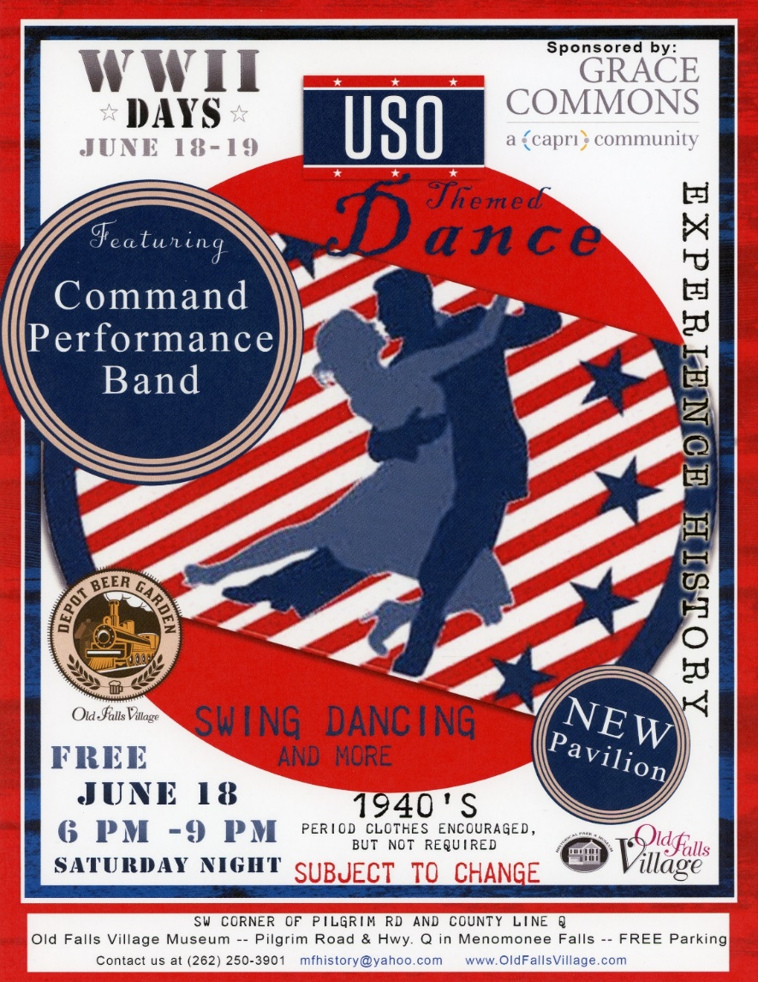
The Swing Band Command Performance Big Band always delivers and amazing time on Saturday night. Our Depot platform was full of dancers all evening. The USO Dance was sponsored by Grace Commons paying the whole $1500 Band cost. The Band is worth every penny. They really bring in the crowd. The Depot Beer Garden was busy all day Saturday and the Depot Grill had the longest lines I have ever seen.

30th annual Civil War Encampment and Battle Reenactment

Maria Pupak and Irene Lape

The weather held out and we were pleased with the attendance. Overall it was a great event.
One of the long-time reenactors had passed away and a celebration of life was done at the pavilion for him on Friday night.

-We featured the battle reenactment this year that was narrated by General Grant followed by a hospital field demonstration and the reading of the Gettysburg address by President Lincoln.

Other scheduled presentations and reenactments that we featured throughout the weekend were
-The Regimental Band played throughout the event on Sunday that featured a sing-along with period songs
-Union Spy Scenarios
-Presentation about the Wisconsin Iron Brigade
-Formal flag raising and lowering
-Presentations from Mary Todd Lincoln “Preserve the Union” and “A Widow Forgotten” by Jessica Michna
-Artillery Drills

We also had some additional booths of Sutlers, books and gun displays and children’s historical games and hobbies. Of course the food was available for purchase by the Society and the beer garden was open with a special band on Saturday by Rogues for Craythur, Celtic music from our own reenactors.
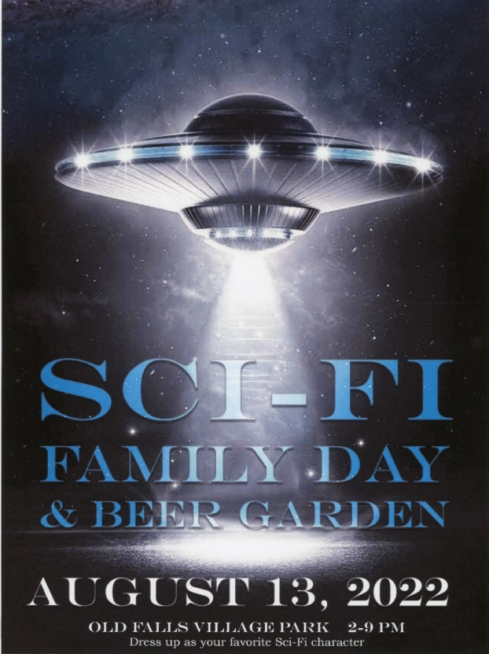
Sci fi Family Days 2022 Report for OFV
Nancy Griefenhagen
Being our first Sci-Fi Family Day mini event for the Depot Beer Garden in 2022, the event went fabulously. August 13, 2022, starting at 2 PM.
We had so many families there enjoying the beer garden and the Sci Fi Event.
The 501st officially were not able to attend, however we had R2D2 come from the Robot group R2-MKE. Also, the Rebel Legion, Al and Lynn, Three Tuskens, Steve and Kim, and Obi Wan Kenobi, all were part of the fashion show. The Fashion show was Emceed by Dave Stout of WTKM who did an amazing job. The whole fashion show was videotaped by Falls Cable Access and two videos were created.
The Costume contest was moved up earlier to accommodate the band starting earlier than I thought. They need a lot of set up time. Henry Osier ran the costume contest and handed out prizes.
The microphone system did not work the best for Henry, but Dave worked the mic well. We need to get a better system. We borrowed the mic and stand and system from my home.
The Menomonee Falls Library had a table of sci fi crafts and worked with almost 200 children.
The mini beer garden activities allow for more people to come to the park.
The movies in the barn were not as well seen. They were older movies: “ET” and “It Came from Outer Space”. The barn worked out great for the movies and is dark enough.
The scavenger hunt with the sci fi figures just placed in the park was great for the kids. They picked up a trading card at each location to collect. 50 cards were not enough for each station, and we ran out. There were 11 stations, and the scavenger hunt sheet was a question about the character and not about the location.
The troopers that came did have the west side of the depot for changing. The depot was guarded by volunteers for entrance. Nothing was going on in the Depot.
Al and Lynn brought a large backdrop, and it was behind the band but could not take it down until after the band left.
We also had a Victor Perrin panel under the pavilion.
The sound system did not do so well for the songs I had for background music. A CD of Star Wars did great and just repeated. My sound effects and fashion show sounds were too complicated to play on the laptop.
No parking issues.
The weather started out looking like rain, but it did not. It was only cloudy. It was about 70 degrees.
Income-The only income was with the Beer Garden and food sales. The sales amount was higher than a usual Beer Garden Day.
Setup-Set up was less.
Make more umbrellas spaceships. It was a hit especially when it would get dark. The entertainment at night was OTR.
Thank you
Thank you to all those who helped. There were so many people and volunteers involved.

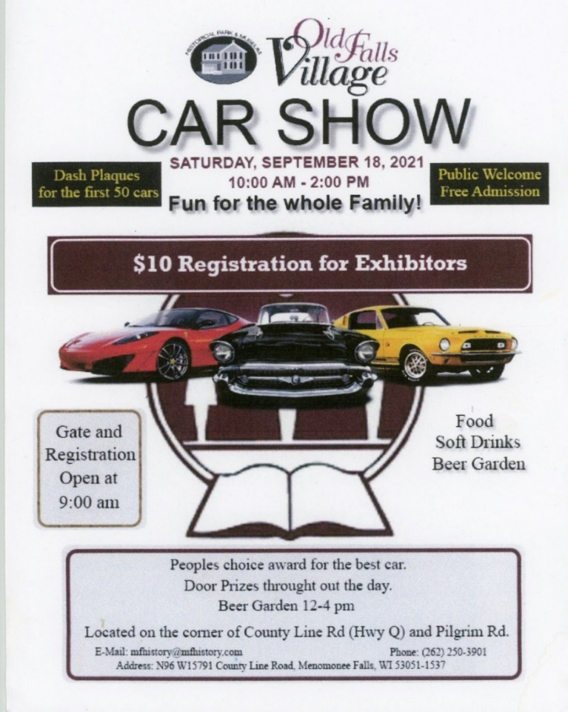
Car Show and Fabulous 50s day.
James Cichy
Event held on 9/17/22 from 12 to 8.
Cars began showing up to the event by 10:30 am, the car show was well attended by patrons and with a large number of cars which filled the parking lot and the large overflow to the east end grassy area. Weather was warm and sunny. Patrons could vote on favorite car and prizes were awarded.
Pat Lynch was the main coordinator of the event
Cost of the event was mainly advertising
Expenses $651.57 making for an 84.43 profit from the show itself
We had Smooth Boar BBQ truck that day and he did well over $2000 in sales which Old Falls Village took in over 200 dollars from the food truck as well as sales of snacks in the Depot Grill.
Beer garden sales we good $2650
Pabst Blue Ribbon in cans were well received by our patrons.
50 music was broadcast in the park and well received.
Music was Cold Front a brass band, they were not well received, did not fit the 50s theme and they were one of the few negatives of the event.
A few patrons did dress up in 50s outfits, would suggest a fashion show/contest in the future.

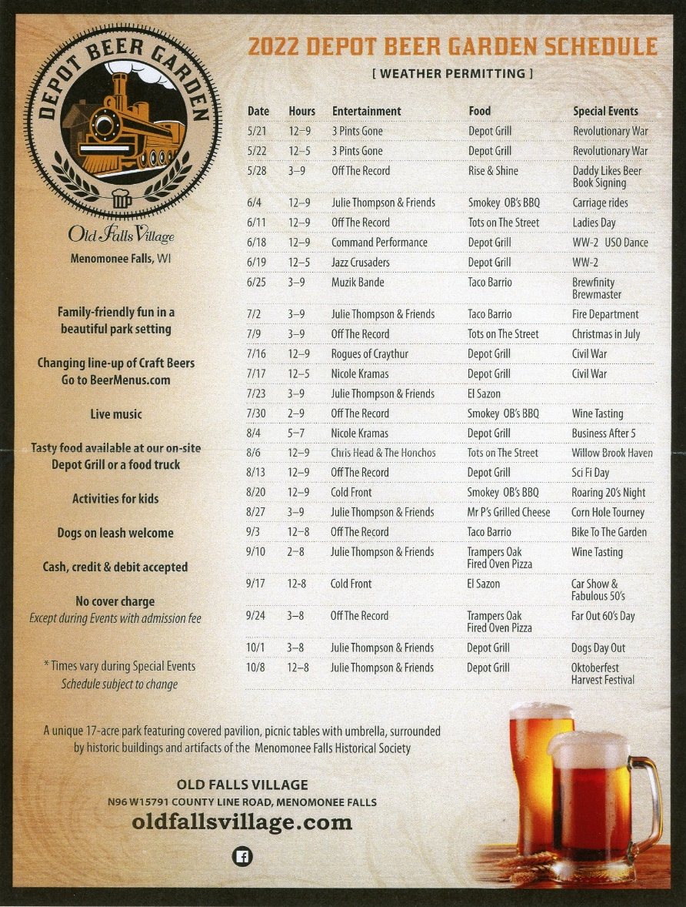
Depot Beer Garden Report
James Cichy Beer Garden Committee Chairman
Dan and Lynn Beine, Denise Cichy Committee members

Overview
The Depot Beer Garden at Old Falls Village Park was in operation 5/21/22 through 10/8/22, 25 beer gardens were scheduled with one date canceled due to inclement weather. What follows is a break down of the various areas of the beer garden operations.
Infrastructure, equipment, environment
A beer garden pavilion was constructed on the northeast corner of the public house on a cement slab that was poured for the pavilion. This became the new home of the perlik as it was locked and covered in its new place for the remainder of the summer. With Todd and volunteers a new path was constructed down to the main pavilion and to the food window from the parking lot to make it safer for our patrons to navigate the area.
Lighting was added to beer pavilion, patio lights were added to the large pavilion, to the west area of the public house and to the firepit area. Stage lighting was enhanced to better allow our musicians to play and for patrons to see the band.
All exterior speakers were rewired and repaired and a speaker was placed on the east front of the depot. An online music service was subscribed to as to have music playing throughout the park during hours of beer garden operation without live music.
A cash drawer was attached under our beer garden serving table to better protect our cash.
Signage was place on the beer garden pavilion acquired from one of our beer distributors. New signage was developed to better display our beer choices above the perlik.
One incident took place with the perlik with all of our gas running out. The perlick was repaired by tightening all the loose valve connections and no further issues were had with the unit.
A popcorn machine was acquired and free popcorn was served at each beer garden, this was very successful. A larger popcorn machine was donated by a historical society member and the original machine was sold for $150.
The Square functions off the hotspot in the office and at times performance of the square is sporadic, we found placing the extra hotspot right at the beer garden improved performance of the Square greatly.
Bartenders, volunteers
Having adequate volunteer staff was often a challenge. We implemented a new policy of bartenders not being allowed to take tip money and this may have had some effect on the number of staff. Denise and myself worked many of the shifts due to the lack of volunteers. During large events we were sorely understaffed and it was a challenge to provide quality service to our customers.
Music, Bands
A large draw to our beer garden is our live music, this can be seen on square data where sales spike as the band takes the stage.
Overall music was well received, yet many suggestions were provided by our volunteers and patrons alike that they would like to see a larger variety of bands and music types. OTR off the record appeared 7 times as did Julie Thompson and Friends. OTR plays a selection of top 40 hits from the last several decades, overall, their set list does not vary from performance to performance. Julie Thompson appears with “friends” so her accompanying performers vary. At times this can have Julie performing more rock type music at other more folk. Julie seems to have a following unfortunately many who come to see her are older, bring their own lawn chair, beverages and snacks thus doing nothing for the beer garden. Cold Front a mainly instrumental brass band performed 9/17 their sound and music had patrons heading for their cars after a short while. For our Oktoberfest we again had Julie Thompson perform, this date would have been better filled by a band with Oktoberfest music.
Recommendations going forward is formation of a music committee, a few volunteers with connections to the music community have already expressed interest to better develop our music choice. Examine the cost benefit ratio of increasing our music budget to increase our beer sales. This past season the band Chris Head and the Honchos was added to our list of performers, they we very well received and should be welcomed back.
Finally, on dates we open early and music is first planned for the evening I would recommend we pursue smaller opening bands that often perform for free yet can bring in a following.
Food
We tried a variety of food trucks this year in an attempt to take some of the burden off of kitchen volunteers and grillers. Overall, the food trucks met with limited success, with one food truck taking in less than $200. Food trucks were to share with Old Falls Village 10% of earnings.
The BBQ truck and the pizza truck were the most successful and agree to come back next year if that is the direction we wish to proceed.
Recommendations that we have 1 or 2 food trucks at our large events such as war reenactments and car show, our crowds on those days would be met by the needs of the trucks. On reenactment days our food service is over taxed, with patrons waiting in line almost 40 minutes to be served. On the car show day this year with a larger crowd, the BBQ truck present took in over $2000 and our share was over $200. So, food trucks for large events and our Depot grill to serve on regular beer garden days.
We added vegetarian burgers and hot dogs on a trial for the depot kitchen, we do make a fair amount of profit so the burgers which are easy to quickly cook up will continue, and we have vegetarian corn dogs that can easily be microwaved as an option as well.
Social Media, advertising
As beer garden manager I took a leading role in promoting our Depot beer garden. A new flyer was produced for each weekend event and posted on our Facebook and website. At times I made copies to distribute to area businesses, most copies made on my home printer. I kept our google page up to date as well as a variety of other media sites. Each week I posted the current beer line up for our beer garden.
We had a presence in the Menomonee Falls Memorial Day parade as my wife Denise and I handed out Depot beer garden business cards along the route and at the 4th of July event when a historical society member volunteered to drive his vintage car adorned with Depot beer garden signs and Denise my wife riding along as beer garden queen, as I walked the route again handing out Depot beer garden business cards.
After the Boy Scout Eagle project of our information kiosk Denise has kept up to date all the information in the kiosk. Denise was also pivotal in developing improved sandwich boards and advertising roadside on County Line Road to further attract patrons in the park.
My goal for the Depot beer garden is to have a large presence in social media at little to no cost to Old Falls Village and without the need for paper flyers which often end up in the garbage.
Beer, Beverages
Soda, in the past there was a “cola war” at the beer garden, in consultation with the beer garden committee it was decided to simply find things and settle with Pepsi, Diet Pepsi and Sprite, these being the same beverages sold at the Depot Grill. Our patrons other than 1 or 2 had no objection to these choices.
Seltzers, in the past we had multiple options for seltzers which made serving difficult as we stored all those varieties in a small cooler. To simply manners one offering of seltzer was decided upon and sales did well
Ciders, ciders have become increasingly popular over seltzers, as such we offered 3 flavors of Blakes Ciders, again our sales did well. Flavors were rotated to reflect change of seasons.
Non-Alcoholic beer, this was again a popular option for some of our patrons, while sales were never brisk, profit margin was good and patrons appreciated the option.
Old School, we offered Pabst Blue Ribbon in cans at WWII, my thought was that for our large events many of our patrons have little interest in craft beers and we needed an alternative. Sales were very brisk and we brought back Pabst for the car show and it sold out, would recommend this offering at our large reenactment events and car show.
Beer/Distributors, we utilized 4 beer vendors this year. 1. Brewfinity, while Brewfinity has been with the beer garden since the start and their Day Drinker beer was our number one seller, we have mainly severed ties with this brewer. Prices were high for their product; Day drinker was number 1 not necessarily because it was a great beer but because it was our lightest beer. Brewfinity collaborated with the Depot beer garden to put on a corn hole tournament, agreeing to work on marketing and provide the first-place prize. When few contestants registered, they pulled out of the deal the day before the event. 2. Capital Distributing, this is a very large vendor while they do offer a large portfolio of beers their customer service was very poor and I did my best not to work with them unless we really needed a product that they had available. 3. Beechwood Distributing, very dependable service with good choices of beers. 4. Wisconsin Distributing, they came on board after seeking us out. Our best choice as a vendor. Their sale person came to the park with tastings of beer we were considering, he followed through with having signs designed for the garden, they have great prices and when ordering 4 kegs of beer the 5th keg was free which obviously is a great benefit.
Beer prices were raised to $7 from $6 in the past, this was reflective of what other beer gardens charge for their craft beers and we heard only 1 or 2 objections to the prices over the course of the season.
Beers, we did our best to focus on small Wisconsin based microbreweries. We would do our best to have a lighter beer such as an ale or pilsner, along with a darker beer and an IPA on tap at all times. We also added various offerings such as sour beers, coffee beers and seasonal beers such as shandy’s and marzens. Our beer offerings rotated on a regular basis and the weekly list of beers was posted on Facebook and at www.beermenus.com. Again, overall, many complements were received by our patrons on our beer offerings.
Keg Killer, a very popular promotion was our keg killer. When a patron ordered a beer and pouring that beer finished the keg, they rang the cow bell and were entitled to a keg killer shirt with the depot beer garden logo or a free beer, most patrons took the shirt, The benefit of this promotion was first in advertising as our patrons would often return wearing their shirts and in beer sales as patrons would work at buying more beer if they were slipped information that a keg was about to empty.
Merchandise
We added a few offerings of merchandise for our patrons, we sold Depot Beer Garden T-shirts for $15, sales were sporadic but worthwhile due to the increased advertising. We offered Depot beer garden logo sticker again with the same results. Finally, we offer rain ponchos for sale and while we never sold any consider keeping as an offering as may help keep patrons in the park if weather suddenly turns inclement.
Events
Smaller themed events
For the sake of brevity, I will not review the events of all 25 scheduled beer garden dates. Overall, we attempted to add a variety of special events or themes to the various dates. We invited an author who wrote the book Daddy Like Beer, the Brew master from Brewfinity to speak on brewing, along with ladies’ day to honor the ladies at the beer garden, bike to the beer garden day, and Oktoberfest. These events were all arranged with little to no cost to the village. Some of these events also included vendors appropriate to the theme.
Our hope with these events that we would open the beer garden at noon instead of 3 pm and have more sales due to patrons being attracted by the event. This did not work out as hoped and sales and patrons were slim between the 12 and 3 time slots, with little benefit to the vendors that setup. In the future I feel that while having a theme for each week is a fun concept, we should no longer open the garden at noon for these smaller events and no longer invite vendors to the events.
We had 2 trivia contest events over the season and both were well received and I would recommend trivia be added on a regular basis.
Large theme events
Our war reenactment events continue to draw in crowds. For these events I would recommend we plan for food and beverage service to begin at 10 am when the events open. Patrons would come up during the 10 to 12 period frequently looking for food and beverage and as stated earlier when food became available at noon the line was 40 minutes long, again potentially look at food trucks for these dates. Also, these events need more volunteers as meeting the need of all our patrons and reenactors is a very difficult task for our small group of workers.
Future Events
I believe we need to evaluate the cost benefit ratio of our events. This year while the sci-fi event was a well-received event, the patrons that the event attracted were mainly families with smaller children. The event did little to improve sales and sales rose that day only when the live music began.
We had 2 wine food pairing events in conjunction with the Art Lounge in Menomonee Falls. Our current beer license allows us to serve beer 2 times each season, we entered talks with the Art Lounge and they indicated that we they hold this type of event at their establishment and that the events usually sell out. Well, our dates were very poorly attended, with the second date in danger of being canceled before I put out a plea to friends who bought enough tickets to keep the event running. We offered wine after the event at the beer garden. Sales of wine were less than stellar and moving forward I do not see a need to add wine to our ever-improving beer garden.
Looking to the future I believe we need to tap in to our connection with Harley Davidson. One of the beer tenders is interested in developing a poker run, a traditional Harley event. Also, July 13-16 2023 is the Harley Davidson 120th anniversary events. The garden should take advantage of this with tours of the Davidson house, and offering bands that would be attractive to the riders.
We had one garden we offered tours of our buildings and I saw a few informal tours take place during the gardens run. I recommend that each garden we have at least one scheduled tour offering of our buildings this could be with a fee or free.

Bottom Line
The beer garden continues to be our number one source of revenue for the Historical Society. While I do not have all the numbers the garden frequently exceeded $2000 in sales on a given Saturday. We took in approximately $5000 in tips for the season, tips were used to purchase pizzas, beverages, and ice cream for our volunteer recognition event. The remaining large sum is being considered to be used in a tree planting fund for the park. I believe with implementing some of my suggestions and with proper conservative fiscal management that the garden will continue to exceed expectations.

Health and Safety Committee Report
James Cichy
In 2022 a new committee was initiated to explore and correct some health and safety issues.
Refrigerator and freezer temperature monitoring, new thermometers were placed in the freezers and refrigerators. Sheets to monitor the temps for safety of our food were placed on the outside of the devices with the plan that the day of each event that Old Falls Village would serve food the temps would be documented. This met with poor compliance.
Areas of safety for severe weather were marked with signs in the case of those patrons especially those patrons who stay overnight for events would know were to go in the case of severe weather. These locations include the upper barn, the Miller Davidson House basement, the Steichen basement and the Umhoefer Cabin basement. During overnight events if potentially dangerous weather is forecast these areas would be unlocked.
An incident report for injuries and incidents to our volunteers and patrons was developed. One incident was documented of a fall, in other cases patrons and volunteers declined to complete the form.
First aid equipment was updated, expired items discarded, the first aid kit in the public house was placed over the water fountain near the entrance to allow
public access to the kit. This kit was in frequent demand by our patrons. Another full kit was added to the lower barn.
Several attempts to procure funding for an AED for the park were made without success. Attempts will continue into 2023.
Pavilion 2022 Report
James Cichy
In 2022 patio lights were added to the pavilion to create a more inviting festive atmosphere to the building, not had by the bright overhead lighting. A new outlet was installed by the electrician to allow the placement of a timer to control the lights. The lights were on for beer garden events, rentals and in the evening weekday hours to draw attention to the park. Picnic tables in the pavilion were sanded of all rough areas and a few boards were replaced. All picnic tables on the grounds were numbered to better allow the reporting of safety issues with a certain table that is in need of repair.

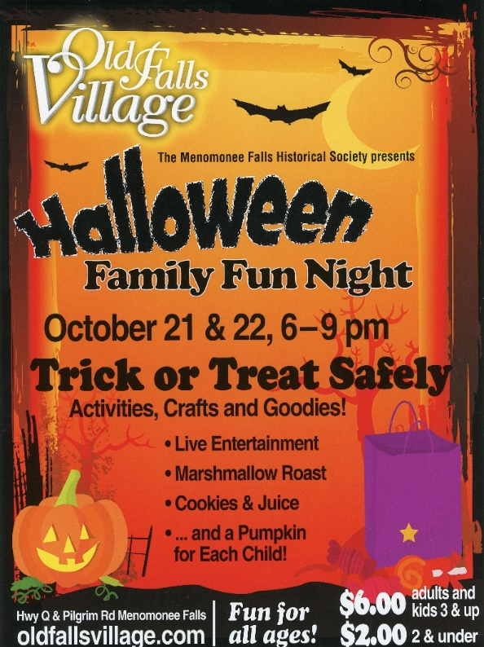
HALLOWEEN FAMILY FUN NIGHTS
Vikki Schmidt
We were not able to have a hay ride again this year and probably will not bring that back as an event.
We had a wonderful magic show both nights and had three showing each night in the upper barn, because of the increased number of people coming to our event. Besides the magic show in the upper barn, we had JK Lee in the Gazebo with a game to pick an event at JK Lee., Debbie Schultz read Halloween stories in the Umhoefer cabin, Monica acted out a skit in the Carriage house of the Dead Man’s Game, marshmallows roasting by the fire pit, cookies and apple juice in the Publick House, crafts were also in the Publick House and pumpkins in the lower barn. There was trick or treating all through the park.
We ran out of candy, cookies and apple juice a couple of times during the event. Thank you to Chris and Diane for helping us out by going shopping
We were also excited to have R2D2 come to our event. He was very popular and the kids had great time interacting with him.
We were given a total of how many people came to our event. This year over 1400 people paid to come to our event. That was even more than last year.
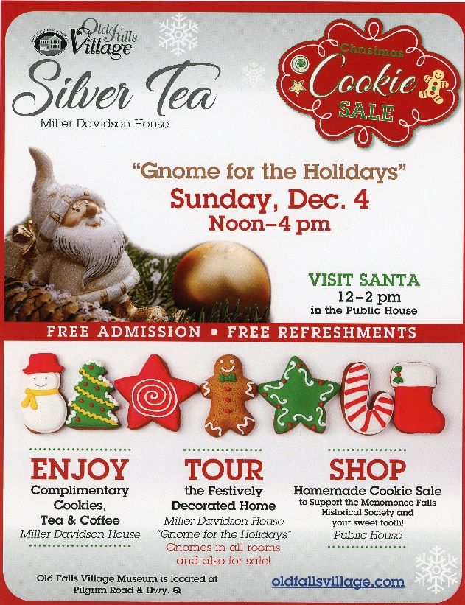
This years’ Silver Tea was the best ever! “Gnome for the Holidays” was our theme, and it worked very well. A few of us ladies got together to make gnomes to decorate the Miller Davidson House, and to sell in the Publik House, and it was so much fun! So many different kinds and so many different sizes. Monika was extraordinarily generous in this endeavor. She made so made ornament sized gnomes! They were all very cute!
The decorations on the grounds were fabulous! What a great job! Beautiful to see after dark!
Once again Chris had the room all ready and set up for the cookie plating Saturday. Her tchotchke table was amply supplied. We girls worked for about 4-5 hours getting everything ready for the sale the next day. As usual, we always get a few in while we’re working who want to buy early. We did oblige, as long as they had correct change.
There were 65 bakers volunteering this year. There was so much bakery, we needed to set up extra tables and use the kitchen counter space. Halfway through the Tea, extra cookies for the dining room had to be taken down to the Publik House to be plated for sale as we ran out!
We had 18 volunteers on Silver Tea Sunday. Everyone did a fabulous job! Men were on the porch greeting the visitors. Docents were in every room, to share the history of the building. The kitchen was humming constantly to keep up with the need for tea and coffee. They also made sure the cookie trays were stocked and the pots out front were full. The dining room was always full of visitors enjoying the treats and beverages.
Tom from the Bargain Express came, as he always does, to capture the event in pictures. Irene made the paper!
After the event was done, we all gathered in the Publik House for a pizza party. What fun! Patty and I were honored for so many years of working on the Silver Tea (over 25 years, we figure-with me being chair since 2009) This was our last Tea. We are hoping someone will take up the challenge next year.
A great time was had by all, and I want to express my appreciation for all the hard work and many hours every volunteer put in, to make this event such a success! We took in over $2100.00!
Facilities Report
Todd Schuman
The following is a list of projects that have been done or are being worked on at the Park over the last year.
Beer Garden Pavilion: Installed a cement pad and Minin Pavilion with the help of many volunteers. Beer garden path was installed and maintained.
Depot: Inside had a ticket both and room installed and was painted. Waiting area benches were built by the Amish for the waiting area. The depot now needs to be set up now as a train depot.
Lower barn: New shelves have been built, freezers have been rearranged along with a wall to section off a maintenance area. Much of the historical tools and artifacts were moved to the Upper barn.
Carriage house: Mural was done on the East side of the building and finished this spring. Spot lights were installed to light it up in the evening hours. The inside was cleaned out to allow for storage of the Menomonee Falls antique fire trucks.
Kiosk and picnic tables: Chase Larson (Boy Scout from Troop 67) installed an informational Kiosk for the park as his Eagle Project. Kevin Lofy, also from Troop 67, lead a group to assemble 5 new picnic tables for the park.
Troop 67: MFHS is the charter Organization for the troop. They hold their meeting in The Public House the 2nd and 4th Wednesdays of the month and the Leader meeting on the 1st Wednesday of each month. The Troop has helped out with many of the events throughout the year. The Troop held a campout in October at the park and did a flag retirements ceremony. The Troop is also storing some equipment in the Caretakers garage.
Koch House: The house is having siding and trim boards replaced over the winter by Miracle Construction. They will be painting the house in the spring once it warms up. The steps were repaired in the spring by member Bob Piedmont.
Miller Davidson Garden: Mike Hecker and others are working to restore the rose garden with a stone path, a bench , a Pergolla and a mix of plants/bushes that will bloom year around. Much of the working is yet to be done in the spring.
Depot Stage: A Sunsetter retractable awning has been purchase that will cover a 20’ x 13’ area. It as been manufactured and will be installed in the spring. This will eliminate the need to set up and take down the popup tents on the stage.
Many other smaller projects were done and there are still many other projects that need to be done.
If anyone would like to help, please contact the Historical Society to help.
I would like to send a huge Thank You to Jim and Denise Cichy, Jim Hernigle, Allen Abrahamson, Troop 67 Scouts and Leaders, Troop 61 Scouts and Leaders, Pack 60 Cub Scouts and many others for the help the have given to the Park over the past year. A special Thank You to Keith Lofy for the use of his equipment. Most of these projects would not been completed without all you!

2022 QUARTERLY MEETINGS
Diane Harley
SPRING
Because of the “TITANIC DINNER” at the Hot House Tavern on April 28, a Spring quarterly meeting was not held.
SUMMER
Our summer cookout/quarterly meeting was held on Sunday, Aug. 14, attended by 47 people. President Richard Burgess summarized the reenactments of the summer. In May we hosted a Revolutionary War event for the first time. It was very successful, and will be repeated next year. The WWII event in June included a flyover and more vehicles than last year, and had great attendance. Nancy Greifenhagen chaired both of those reenactments. This year was the 30th year for the Civil War Encampment, and it was chaired by Irene Lape and Maria Pupak.
The Saturday Beer Gardens have been managed by Jim Cichy. They have been our #1 fundraisers because of the good beer and food. (The food trucks have not been as successful as we had hoped.)The beer has been dispensed from the Perlick, which is now situated in a mini-pavilion on the east side of the Public House. More volunteers are needed to help with both food and beer.
On Aug. 13 the first Sci Fi gathering was held, complete with a fashion show, R2D2, space movies, light sabers, etc. It was enjoyed by all who attended!
The Car Show will be held on Sept. 17th, from 1 – 4.
The Volunteer Appreciation event will occur on Sept. 24.
Halloween Family Fun Nights are being planned by Vikki Schmidt for Oct. 21 and 22.
Jill Schmidt is the chairperson of the Silver Tea/Cookie Sale which will be held on Dec. 4.
Richard then discussed capital projects. The Depot ticket booth is done, and there are new benches. The plan is to make the Depot into a railroad museum. The Koch House needs carpentry work and painting. The path across the railroad tracks leading to the pavilion will be paved this year. The deck on the back of the Public House needs to be replaced.
Deb Schultz asked about new or remodeled restrooms. Richard said that is our #1 objective, but the cost could be as high as $115,000.
A member of Morning Star Productions explained how their interactive theater events work. This year’s event is an adventure in which you can become a Patriot spy in the Revolutionary War. They usually perform At Wooded Hills Church, but may begin using our grounds.
Maria Pupak won the raffle of a Brewers Bobblehead, poster, and baseball cards. Kathy Bozek and Tom Staats were the winners of the Trivia Contest.
A meal of hamburgers and hot dogs (grilled by Mike Hecker), salads and desserts was enjoyed by all our guests.
FALL
At the Oct. 10 Board Meeting Richard Burgess announced that he would be resigning as president of the Historical Society to become president of the newly-formed “Friends of Old Falls Village”, as part of a new management model to run the park.
Because of the uncertainty of the role of the Historical Society and the many questions that needed to be answered, the Fall Quarterly Meeting was canceled so that we could concentrate on those issues.

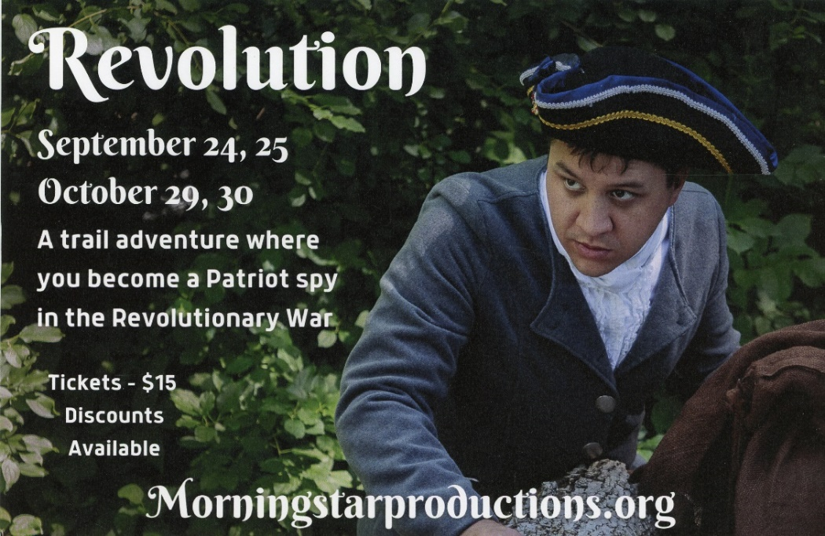
Morningstar began use of our buildings and grounds in 2022. The MFHS board was provided with scant information of what the use of our grounds and buildings would mean for our park. Communication with the MFHS was poor or nonexistent on Morningstar’s part. Garbage created by Morningstar events was left on the grounds uncollected, golf cart left outside, buildings left open, alarm system use issues to the point of the MFHS having to disable the alarm leaving our buildings at risk. Morningstar took over the lower barn storage area, space heaters left on overnight in buildings. Agreed upon payment to the MFHS from Morningstar was not provided in a timely fashion.
“Friends” plan is to turn our School House over to Morningstar, the draft proposal reads “ Morningstar Productions shall have precedence for use of the School building”. Our Historic School House has now become a play prop!
This is the condition of the school house now: our artifacts are covered with their belongings and shoved into corners. It has been a month since their last performance. A tub of grease left sitting on the counter. Garbage can overflowing. Misuse of candles, candles used near the ceiling, 5 space heaters in the house. Dried out evergreen branches on the fireplace. Propane tanks, matches, lighters left out, this building is an ad for a fire disaster all in Morningstars making.
The Menomonee Falls Historical Society is responsible for our entrusted buildings, artifacts, furnishings and equipment.
Morningstar productions was granted access to our park and buildings in 2022 with verbal agreements with former president Richard Burgess. Resolving the numerous issues we have encountered this past year with Morningstar without a written contract between Morningstar and the Menomonee Falls Historical Society, has been difficult. We hope to enter an agreement with Morningstar that would protect our interest in the park and allow for Morningstar to hold its historical productions.
The executive board has a plan to move forward with a written contract, first to present our ideas and requests to Morningstar, then if agreed upon by Morningstar to have Nathan Bayer a lawyer skilled in working with nonprofits write up a legal contract. This contract then would be subject to a yearly review for any potential modifications. Morning Star has stated they will wait for an agreement until “Friends” has been sanctioned by the Village Board.
Rentals
Chris Schultz, Diane Harley
The Historical Society rents the meeting room in the Public House, the Pavilion and several sections of the grounds. The room can be rented almost any time of the year, except on the Saturdays from May to October during the Beer Garden
In 2021 there were 14 rentals during April, May, June and July. These rentals brought in $2,242.50.
In 2022 we had 3 birthday parties, 4 picnics, 3 bridal showers 1 reunion, 1 memorial, 1 graduation party and 1 anniversary party.
The seventeen rentals were held in May. June, July, August, September October, November and December. These rentals brought in $2,725.00 Everyone was very pleased with the facilities and commented how nice the grounds look.
Information about renting our facilities can be found on the website Old Falls Village. Con, or by calling 262-250-3901.
Volunteers
Chris Schultz, Jordan Euclide
One of the most important things to make our events go well is volunteers.
Setting up for the events needs lots of volunteers.
There’s always a need for guides in the houses, people to do the admissions and parkers to direct traffic.
Then there’s the beer garden. Jim & Denise did a great job making it a success, from getting volunteers to pour beer to coming up with added mini events.
Food was served during the Beer Garden. Along with the food trucks the Society also served food. Some of the trucks went well, some didn’t. It takes 3 to 4 volunteers to staff the kitchen to insure good service.
The committee thanks all the volunteers that made our events something everyone should visit.

Accessions
Chris Schultz
In April, Emmie Corbin, a junior at Hamilton High School asked if there was something she could do for us as she is interested in history. She will be inventorying the artifacts in each room of the MDH to be sure what the “cheat sheet” says is in the room is correct.
First, she did the porch, then the fireplace room. In August we started the inventory on the second closet of the master bedroom. Many items were found that should be in other places., likes books and a child’s rocking horse. Also found was a 1925 ledger book from the Justice of the Peace listing various names & their crimes.
In September we went through the clothes closet in the guest room. It holds clothes volunteers could borrow when guiding during an event. Some were moved to the closet in the maid’s room.
Emmie, Monika and I started the large closet; it was the bathroom and now holds artifacts. Quilts, dresses and numerous other items are stored there.
As Emmie returns to school this month we’ve suspended our project. Hope to start again in Spring.
Diane Harley and Irene Lape
On December 1, 2022, our membership totaled 200.
Student 1
Individual 14
Over 65 36
Family 107
Pioneer 16
Homesteader 7
Lifetime 8
Complimentary 11
NEWSLETTER
Jordan Euclide
Due to unforeseen circumstances I was only able to get one newsletter out this year. I am hoping to send one out quarterly in the new year. I am trying a new tool to change up the look of our Newsletter this year. If anyone would like to submit an article, just send it to: oldfallsvolunteer@gmail.com.

PARADES
Monika Oeltjen
The Historical Society participated in two parades in 2022, the Independance day and Christmas. On the 4th of July we decorated the golf carts that carried the candy and any weary walkers. Jordan and Spencer Euclide drove one cart and I, Monika Oeltjen drove the other. Candy and Icees was passed out by Historical Society members Carolyn and Joe Nehmer, Angela and Vanessa Oeltjen, and Stella Keehan. Some of the participants sported WW2 era costumes while the others were patriotic in Red White and Blue. am not sure the number of pieces of candy but with the donations we had more than last year and we still ran out before the end of the parade. In addition our golf carts Jim and Denise Cichy recruited their friend, Dave, who had a Model T to drive with us in the parade. Jim and Denise handed out Beer Garden fliers to the parents.
The Christmas Parade was fun! After decorating the golf carts for the parade, the weather decided we needed to make a last minute switch to the Oeltjen's car so Diane Harley and the Oeltjens decorated it up. With Ron at the wheel and the antlers in place(on the car) we headed out! Diane , Angela and Vanessa manned the buckets of cardy while I tried to keep refilling! It was a bit chilly but we popped the back hatch, sporting our holiday colors, and the candying began. We had leftover candy from Halloween, which was soon gone, but this parade we actually hand candy to the end! The weather (though not right for carts) was wonderful for attendance to the parade. So many smiling faces.
HISTORIAN REPORT
Jill Schmidt
January
- Paul Wolter contacted me about sending him any info and pictures from Menomonee Falls that pertained to the great snowstorm of Feb. 22,1922. He was putting together a presentation about this event in Sauk Co. I sent him articles, but we had no pictures.
- I came across a letter written in February of 1926 by Judson E. Hoyt (Dr. Wm. Hoyt’s son) to his grandson who was turning 8. It is a 15 or so page letter, describing many aspects of life in Menomonee Falls back in 1866, when Judson was eight or so. While transcribing the writings, I came across his memories of school days spent in what is now the school house, now located here at Old Falls Village. It is a fun and interesting read. I made note to the docents of the school house that many things he wrote about could be useful in the tours of the building.
February
- Articles and pictures were sent to Tom Brant in reference to the American Legion. He is making a display in their front entrance.
- Theresa Ziolkowski requested info on the original condition (log cabin?) of the house she now lives in. N87 W14847 Fond du Lac Rd. No information could be found.
- Frederick Nehs was the Citizen Spotlight for February.
- Buzz Saw. We had made these at one time with buttons. That proved to be too expensive. Jeff Steliga says he can make them with the wooden discs much cheaper. We can use these in multiple ways, we can sell them in the depot, they can be used during the school tours with the children who are too young to tour the houses. As of yet these have not been made.
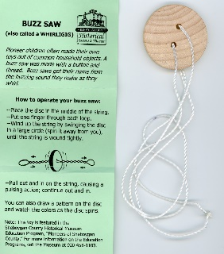
March
- Larry Obermann has requested a Century Family Certificate. He is a descendant of John Le Roy Obermann who was born in Menomonee Falls Feb. 3,1920. He has submitted the proof of lineage and other family information which will be kept in the family archives at the library.
- The Spring Landmark magazine has come out, including my article on Francis Walterlin Sr. Despite the fact he misspelled my name, and Elisabeth’s name is not Elizabeth Becker, it’s Elisabeth Becherer, it’s a nice short account of Mr. Walterlin.
APRIL
- Larry Bennet donated an old newspaper showing his father working on construction of the Lepper Dam. He also donated a Centennial Coin and a 1940 yearbook. All were taken to the library history room.
- Larry Obermann got his Century Family Certificate and sent in a pic of himself with it. It was put on Facebook.
- My new presentation “Up the Big Hill” was given to the seniors at Emmanuel Methodist. There were 20-25 people in attendance, and we received a $50 donation.
MAY
- There was a request for information on the family of Peter Somers, by his great granddaughter. Her family intends a trip this way to see where the homestead used to be. I sent information from Census and Platt Maps. Got her a copy of the original Patent for the homestead land and an overlay showing what is there now. Also, every newspaper article from our local paper up till 1935 with that or a variation of the Somers name.
- The Falls News index through 1936 has been completed and is being added to the spreadsheet.
- LANDMARK magazine has published my write up on Garwin Mace, the owner of the Lime Kilns and first Village President.
- Kimberly Boggs has requested 3 Pioneer Certificates. One each for her and her two siblings, Benjamin Boggs and Patricia Schmidt. They are all descendants of Johann Fuss (settled in 1845) and Johann Adolph Birkhauser (settled in 1849).
- Inquiry made on has the fourth of July Parade always been held on the 4th? No it has not, but date of when that started hasn’t been tracked down yet.
- LANDMARK has published my story on William Hesk, the first settler here in Menomonee Falls.
- My Up the Big Hill presentations was given at Highlands @ Wildwood Lake Apts. On May 12th to about 40 people. We received a donation of $50.
June
- The Art Walk was a big success. From 1-4 pm the Lion’s Club sponsored a bus tour to see 7 completed and one in progress mural. Along the way, as the guide, I also pointed out historical buildings and gave a bit of the history of each. There were about 8 tours, lasting a little over 20 min. each. We began on the bridge at the falls, went up to the 4 corners and turned down Appleton Ave. Next up Pilgrim to Old Falls Village and then back to Main St. and our starting point. It was extremely hot that Friday, but the tour van was air conditioned. I look forward to doing this again next year. It was a lot of fun!
- Kim Boggs received her certificates and set a picture with her siblings holding them. It was posted on Facebook.
JULY
1)July Citizen Spotlight was on Maude Shunk our long-time librarian here in Menomonee Falls. This episode can be found online at Falls Cable Access on Facebook, as are all Citizen Spotlights and Talk of the Town episodes.
AUGUST
1) Aug 2 was my presentation at the library with my new Streets of Old Menomonee Falls, part 1, Up the Big Hill. Quite a few people in attendance. It was video-taped by Falls Cable Access Channel 14 and simultaneously streamed on U Tube, where it is still accessible at any time for viewing. I would like to thank Jim and his wife for being there. Their support meant a lot!
2)My story on Doc Burkhardt was printed in the LANDMARK Magazine. Interesting info on one of our early country doctors.
3) Joyce Krzynski donated Burg, Claas and Holzem family pictures and funeral cards, which have been scanned and catalogued at the library for future genealogy use. Please keep in mind, we are looking to scan old photos of Menomonee Falls families. If you would like to donate or just let us scan them, it would be appreciated. Also, please don’t throw out your old family funeral cards. We will take those too. Just contact me.
4) Michelle Frie contacted us about Christmas tree lighting traditions in the Falls. Sent her the article about our first Community Christmas tree, Dec 1925.
5) Cathy Burton sent in a request on behalf of her father, George Helwig Jr. He told her he worked at Sparta Trailer Park in Menomonee Falls years ago. There was a model trailer on display on top of the hill. Also an ice cream place was within walking distance. The only trailer park I ever knew of in the Falls was Bill’s, on Appleton Ave.
A search came up with a Sparta Trailer Camp in Meno. Fls. But no address could be located. Ray Etzel says it fits the description of a park in Germantown west of the expressway south of Friestadt Rd. If anyone has more info please let me know.
September
1) We were contacted by the UWM Cultural Resource Management. Menomonee Falls is planning a reconstruction of Menomonee Avenue between Appleton Avenue and Town Hall Road. New pavement, reconstruction of the storm sewer, and improvements to bike, pedestrian, and parking accommodations. UWM CRM has been contracted to complete the architectural and historical review of the project corridor and asked for our input. Notice was put on multiple Facebook sites and consensus is there is nothing of historical significance that will be damaged with this upgrade. If you have information to the contrary, please let me know.
2) John Scott from Brookfield wanted to know if we had any idea how he might find a photo of his great great grandparents’ John and Anna (nee Hansen) Kohl farm that was originally located directly across Appleton Avenue from the now Meno. Fls. High School? Search at the library came up with only a picture of the couple. Facebook also came up empty. If anyone has info please let me know.
3) A wooden container that had been used as a door stop for many years, before throwing it out, was opened and inside was found a grave stone for Eva May Connell, daughter of John and Catherine Connell here on Old Falls Village property. A search found she is buried at Union Cemetery in Meno. Fls. and has a marker to match the rest of her family’s, although the dates don’t quite match. Will contact the cemetery to further investigate this. Reached out to relatives on Facebook to see if anyone wanted it, no takers.
4) Received my Shining Star Award from the Greater Menomonee Falls Foundation. Dinner at the North Hills Country Club. It was quite an honor!
5) My August presentation was seen on UTUBE by Nancy Grunwaldt, from Slinger. She and her cousin Chris Stukel from IL and I got together at Fiddleheads for coffee to discussed their great grandfather Frank Koehler, his wife Catherine (nee Schunk) and their family. Both girls are descendants of Franks’ son William. I collected vast amounts of information on the Koehler and Schunk families also many pictures. All will be scanned and added to the genealogy files at the library.
October-November-December
- Carole McGibany, Nancy Griefenhagen and I are coming up with a way to do walking tours of Menomonee Falls. Nancy came up with the idea of placing a QR Code at certain locations in town. When that code is scanned, historical information and pictures about that spot will come up on the users’ device. I have already sent Nancy my complete write up on my last presentation “Up the Big Hill.” These will be the first locations used. Carole’s Fussville presentation will also be used. All subsequent presentations will be added. This seems a very worthy and exciting undertaking!
- Clyde Henningsen, who lives in Arkansas, was in possession of one of George Neu’s Ginsing crates. He has since mailed it to me and I will be using it in my historical presentations.
I would like to thank the Menomonee Falls Historical Society for allowing me to do the Annual Report these last few years. This will be my last one. I do so hope someone picks it up and continues this invaluable piece for our files.


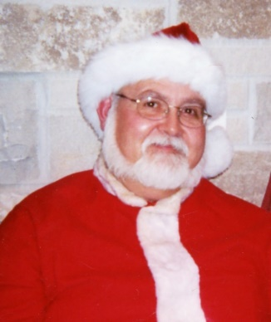RIP Jack Tindall (former board member) Dec 2022
